# **M5StickC IMU Sensors**

**Introduction -** This lab is to demonstrate understanding of some basic functions of the M5StickC Plus. I am utilizing the sketch for “IMU” and for “Blink”. Modifications were made to the original sketches to make them work for the objectives.

**Objectives** – Design, develop, and utilize software for IoT devices, systems and applications. Design, develop, and implement IoT device(s), product(s) or application(s). Create IoT systems that integrate multiple devices and sensors.

**BoM** = M5StickC Plus, USB to USBC charging/connecting cable, Desktop PC

https://youtube.com/shorts/QrQ8Zd4OIDA?feature=share

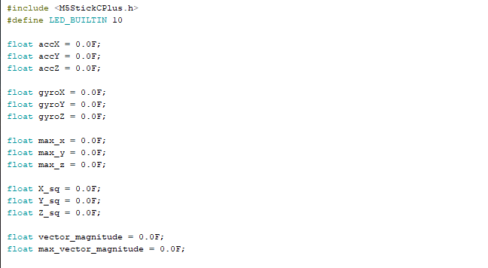

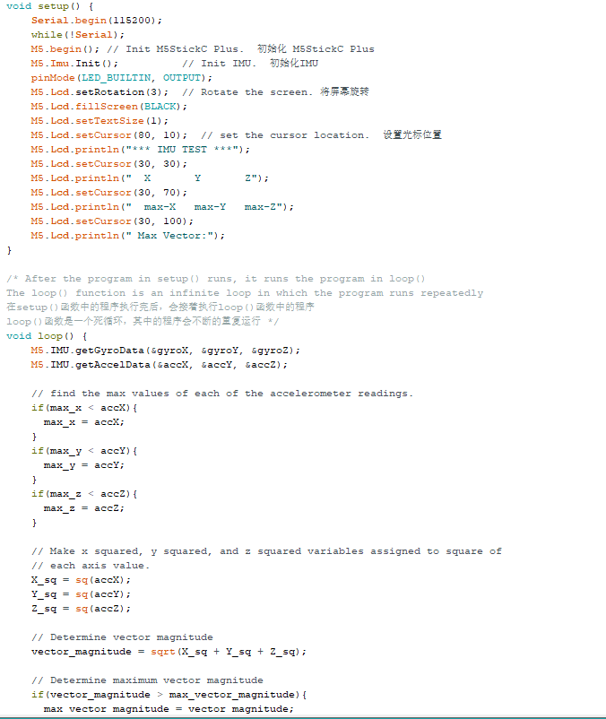

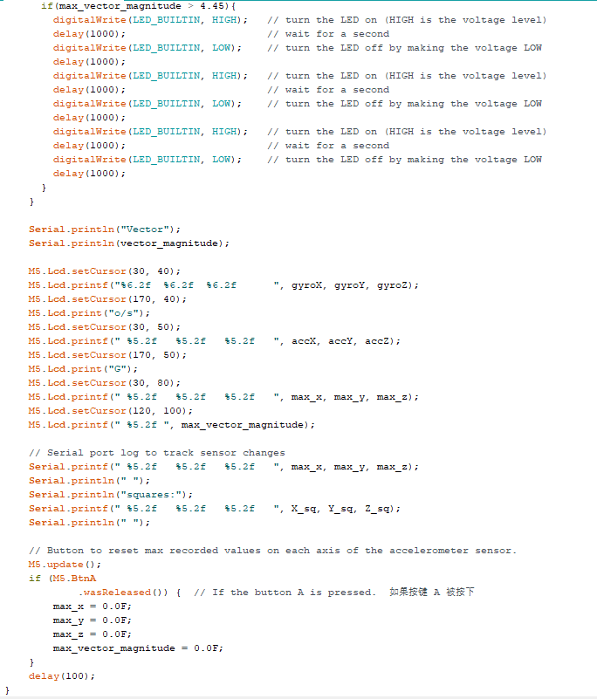

This program displays real-time sensor data from the accelerometer of the M5StickC Plus, displays and stores the highest recorded values from each axis of measurement, allows for resetting of the values back to zero on button press, performs abstracted calculations using the stored values, uses logic statements to determine activation of the LED light, and blinks the light three times if the conditions of the logic are met.

Calculations for this lab included the square value of each axis accelerometer value, and the square root of the results for each of those calculations. Also I took 14 different results of the acceleration rate of a 10cm drop and divided the sum of those by 14 to get an average to ensure accuracy. The average is used as a condition in the logic of the program that activates the blinking of the LED light.